**Restaurant Management System**

**STAKEHOLDERS**

|  |  |
| --- | --- |
| **ACTOR** | **Handle patient registration, billing, and insurance processing.** |
| Chef | * Full Access of system |
| Restaurant Manager | * Utilize the system for Customer and generate all bills in excel at EOD. * Update menu every day as requirement. * Update a feedback form in system everyday |
| Waiter | * Limited access to system. * Provide a feedback form (paper) to each customer. * Waiter cannot update a menu, only for generate bill |
| Customers: | * Indirect stakeholders who will interact with the system through generated bills and provide feedback that will be entered into the system. |

**1. As-Is Process Map (Current State)**

* Purpose: Illustrate how the restaurant currently operates using a paper-based system, which includes manual tasks and inefficiencies.

Steps:

* + Order Taking: Waiters write down orders on paper.
  + Billing: At the end of the meal, waiters’ hand over a paper bill to the customer.
  + End-of-Day Reporting:

Managers enter each bill into an Excel sheet.

Generate daily sales and item sales reports from Excel.

* + Menu Update: Managers manually update and distribute menu copies.
  + Table Reservation: Reservations are handled verbally or manually noted.
  + Access Control: No access differentiation for managers vs. waiters.
  + Feedback: Paper-based feedback form is manually inputted later.

**2. Future Process Map (Target State)**

* Purpose: Demonstrate how the digital Restaurant Management System will streamline operations with automation and role-based access.

Steps:

* + Order Taking:

Waiters enter orders directly into the system via tablets.

Orders are sent to the kitchen screen automatically.

* + Billing:

Bills are generated in the system, linked to the order details.

Payment options are integrated for card/cash payments.

* + End-of-Day Reporting:

System auto-generates sales reports.

Managers can view real-time daily, weekly, and monthly sales reports.

* + Menu Management:

Managers update menu items in the system.

Changes reflect across all locations immediately.

* + Table Reservation:

Managers can reserve tables within the system.

Waiters check the system for real-time reservation status.

* + Access Control:

Role-based login: managers have full access, while waiters have restricted access.

* + Feedback:

Digital feedback captured at checkout, reducing manual entry.

**Scope of the Restaurant Management Software**

* The scope of Restaurant Management System (RMS) is designed to transform restaurant operations by automating and digitizing processes, addressing inefficiencies in order-taking, billing, feedback, and reservations. It introduces role-based access, allowing managers to update menus, generate reports, and oversee reservations, while waiters handle order entry and billing through an intuitive interface. Customers benefit from faster service, transparent billing, and improved engagement through digital feedback. The RMS provides real-time insights with automated sales and performance reports, helping optimize menu offerings and boost revenue. By replacing the manual, error-prone workflow with a secure, efficient system, RMS enhances operational efficiency, customer satisfaction, and data-driven decision-making, positioning the restaurant for sustained growth and success.

**The main features that need to be developed.**

System should be able to create a menu. The menu should be categorized into following sections:

* Starters
* Soups
* Main Course
* Desserts
* Drinks

1. Every item in the menu stored should be categorized into any one of the above heads. Each item should be saved in the system along with its price. For example, Green Thai Curry - price $12, Pasta – $10 and so on. This menu should be created and edited by the managers only. They should be able to add new items, delete existing items, as well as create new menus from scratch.
2. Waiters and managers should be able to search items in the menu using the search facility.
3. Every waiter and manager should have access to the software. Waiters shall use this system for generating the bill table wise. Every bill shall be tagged to the waiter generating it and the table number. Waiters cannot edit the menu. Waiters shall use the system only to generate bills.
4. The system should be able to reserve tables. This reservation would be done by managers *only*. The waiters shall not seat anyone on the tables reserved. The waiters shall look into the software to determine which tables need to be reserved. The table layout is to be stored in the system.
5. Management wants certain reports at the end of the day. Please give the report formats for the following reports:

* Total sales of the day by dine in customers
* Total sales of the day by home delivery customers
* Total sales of the day (home delivery and dine in customers consolidated)
* Name the top 10 most sold dishes for the day
* Total sales every weekend (to be done by inputting the dates)
* Total sales every month (to be done by inputting the dates)
* List of dishes not sold in the current month (this is to phase out dishes that customers are not ordering)
* Total sales across all cities
* Total sales for each city

1. Login for waiters, managers, and James Oliver (CEO). Change password facility to be offered.
2. Customers can pay by cash or card. There should be a payment gateway on the system.
3. System should be able to generate the bill.
4. James Oliver would like a feedback form (paper) to be given to every customer. This form shall capture details like name, address, mobile number, email, date of birth, anniversary dates of the customers, and their feedback. These details shall be added by the manager manually into the system.

**3. Scope of the Restaurant Management Software**

**The scope outlines the key areas and features to be developed. Here’s an example:**

**In-Scope Features:**

1. **Menu Management**: Create, edit, and categorize menu items (e.g., starters, main course, drinks).
2. **Billing System**: Allow waiters to generate bills table-wise and tag bills to waiters.
3. **Table Reservation**: Managers can reserve tables and view table layout.
4. **Sales Reporting**: Generate reports such as daily, weekly, monthly sales, top dishes, and total sales per location.
5. **User Management**: Roles with restricted access (managers, waiters, CEO).
6. **Payment Gateway Integration**: Allow customers to pay by card or cash.
7. **Feedback Collection**: Record customer details and feedback.

**Out-of-Scope Features:**

**Customer Loyalty Programs:** Not required for this system.

* Loyalty programs, such as reward points or membership benefits, aim to encourage repeat visits by offering incentives to customers. While valuable, these features are not included in this system as the primary focus is on operational efficiency and standard customer feedback collection, not on advanced customer retention strategies.

**Advanced Marketing Analytics:** Beyond standard sales reports**.**

* Marketing analytics involves analyzing customer data to identify trends, behaviour, and preferences to tailor promotional campaigns. While the RMS offers basic sales and performance reporting (e.g., top-selling dishes, daily revenue), it does not include detailed marketing tools like predictive analytics or segmentation for campaign optimization. Such features are typically part of a dedicated marketing system**.**

**Integration with Third-Party Services:** E.g., external reservation platforms**.**

* The RMS does not support integration with external services like third-party reservation platforms (e.g., OpenTable). Instead, it manages reservations internally within the system to keep the workflow simple and focused. This limitation avoids the complexity and cost of external API integrations.

**In-depth Customer Profiles:** Apart from basic information collected in feedback forms**.**

* The system collects basic customer details like name, contact information, birthdays, and anniversaries through feedback forms. However, it does not support creating detailed profiles with purchase history, preferences, or dining habits. Advanced customer profiling requires more complex data analytics and storage, which are beyond the scope of this project**.**

**Functional and nonfunctional requirements**.

**Functional Requirements:**

1. **Menu Creation & Management**:
   * Managers can create, edit, and categorize menu items.
   * System allows for price entry per item.
2. **Order and Billing**:
   * Waiters can generate table-wise bills.
   * Bills are tagged with waiter name and table number.
3. **Table Reservation**:
   * Managers can reserve tables and block them for reservations.
   * Waiters can view reserved tables but not edit reservations.
4. **Reports Generation**:
   * Daily sales by dine-in and home delivery customers.
   * Monthly and weekly sales, top 10 dishes, and unsold dishes for the month.
5. **User Access Control**:
   * Waiters, managers, and CEO have different levels of access.
   * Login and password reset functionalities for all users.
6. **Payment Processing**:
   * System allows card or cash payment with a payment gateway integration.
7. **Feedback Collection**:
   * Managers can enter customer feedback into the system.

**Non-Functional Requirements:**

1. **Usability**: The system should have an intuitive interface for both managers and waiters.
2. **Reliability**: It should handle billing and orders reliably during peak hours.
3. **Performance**: Reports should be generated quickly without noticeable lag.
4. **Security**: Sensitive information (e.g., payment data) should be securely stored and accessed.

|  |
| --- |
| **AS-IS Process** |

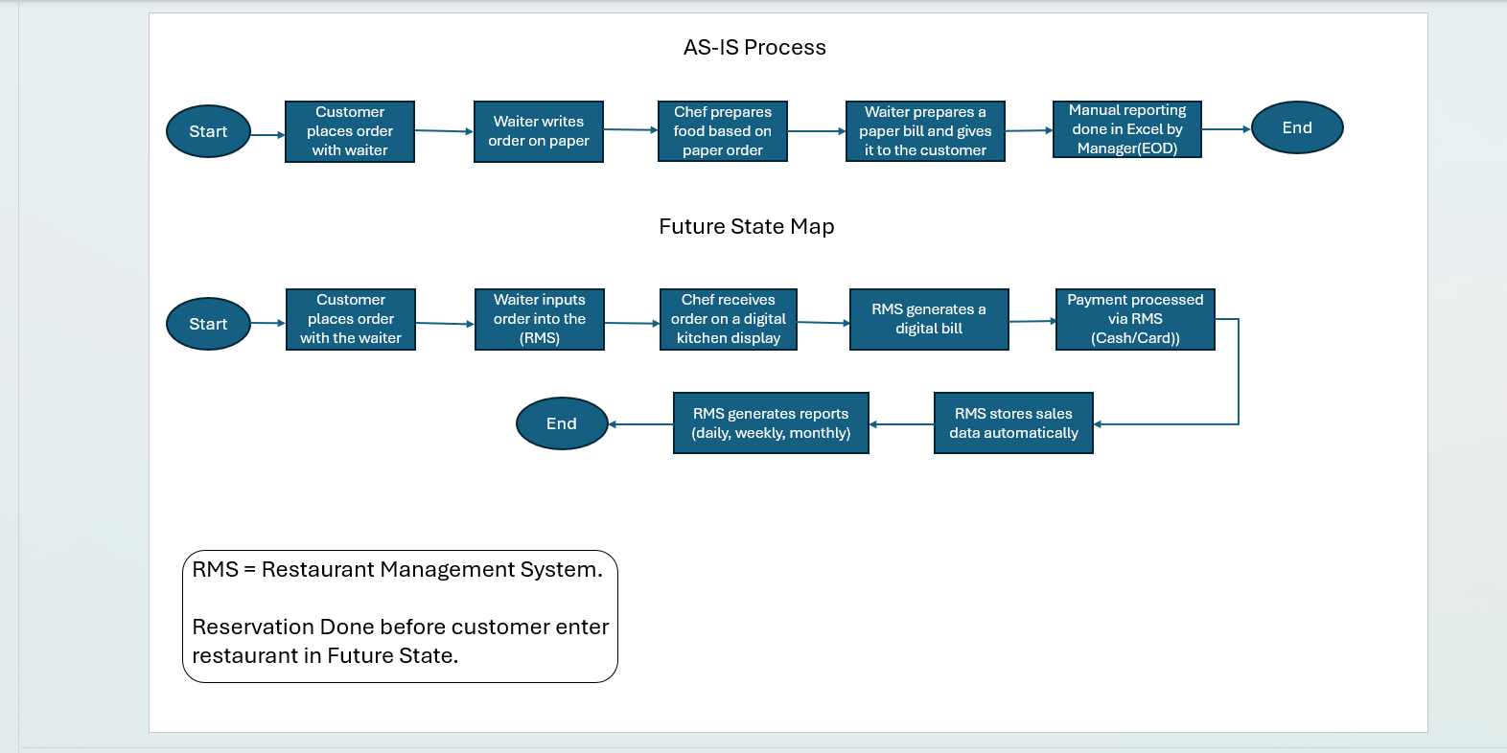

|  |
| --- |
| Wireframe of Restaurant management System (RSM) |

**ASM PROJECT**

**TABLEAU PROJECT**

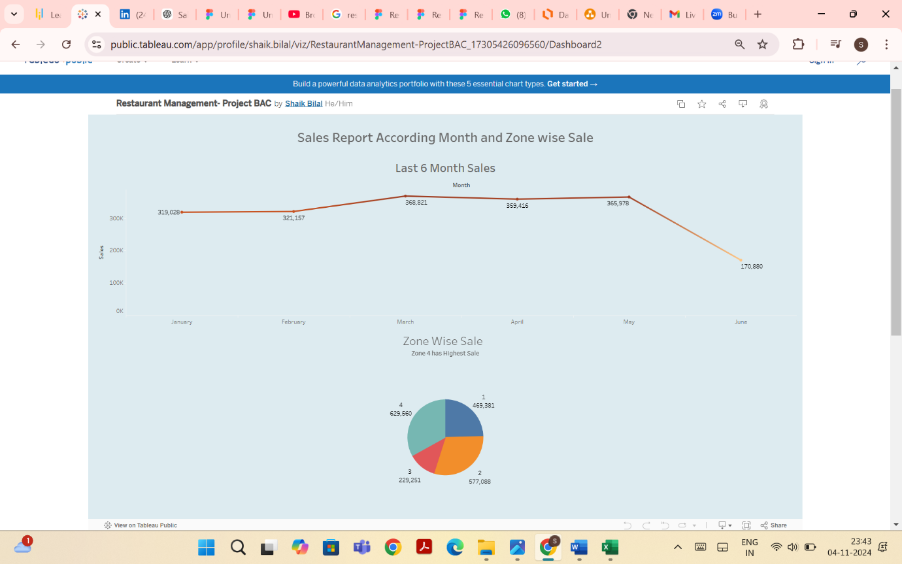

**EXCEL PROJECT**

